Wyatt’s Guitar Practice

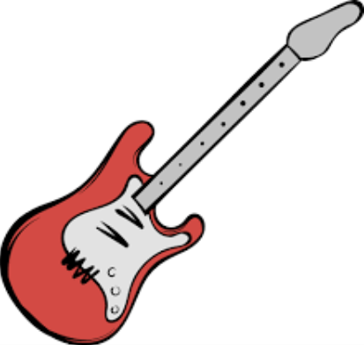

T
A
B

T
A
B

T
A
B

T
A
B

